# Required Assignment 8.2: Analyze a Conjoint Analysis Report

**Anupam Shringi**

**Suggested time:** 120 minutes.

**Assignment Instructions**

Include the following in your submission:

1. Go to Conjointly and sign-up for a free account.
2. After logging in, click on “My experiments” on the menu on the left side.
3. Out of all the experiment results, click on the ‘report’ button of any that interests you.

***Note****: This is a required assignment and counts towards programme completion.*

**Step 1: Testing Car preferences across various brands, price points, transmission types and engine types**

Setup of the analysis with brands and features:

1. 4 car brands:

1. 5 price points:

1. 2 transmission types:



1. 3 engine types:

**Insights from brand preferences:**

**Insight:** Maruda Maru II and Ladina Klubnika are the models for which multiple potential combinations of features of engines, transmissions and price points that are preferred by customers within the study. For Landrange Hoover there are lesser number of feature combinations that can be seen, and Kea Rocketta has the least number of feature combinations preferred by customers in the study.

**Attribute importance for various models:**

**Insight:** For Landrange Hoover and Ladina Klubnika, drive away price and transmission are the important features for customers. However, for Maruda Maru II drive away prices, transmission and engine types are important. For, Kea Rocketta only drive away prices are important to the survey population.

**Preferences for levels:**

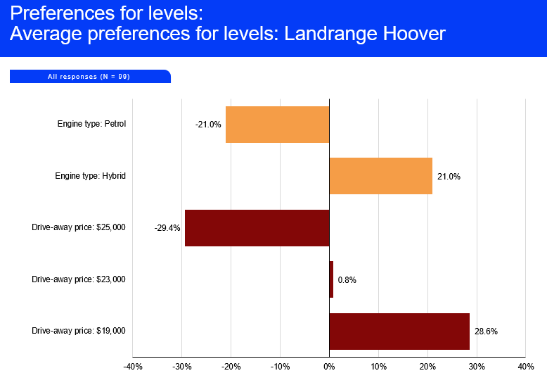

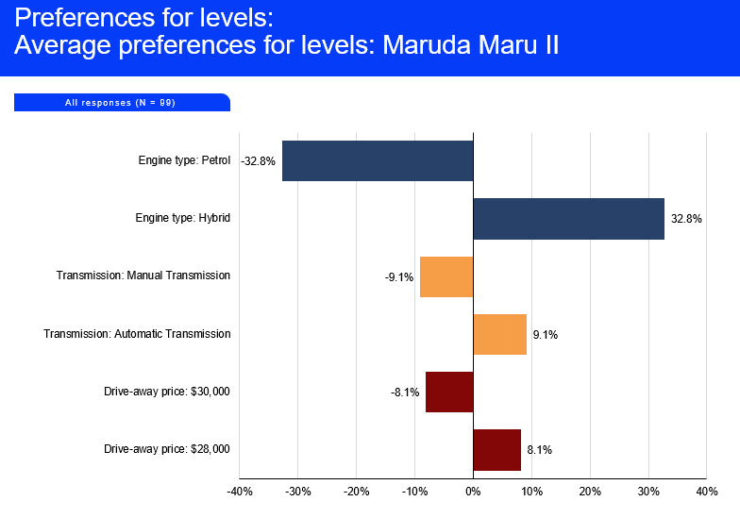

**Insight:** For Landrange Hoover, customers want a hybrid engine and a price point of $19K. However, for Maruda Maru II, hybrid, automatic transmission and $28K price point is preferred.

For Kea Rocketta, people just want a low price point of $19K. However, for Ladina Klubnika, automatic transmission, and price point of $19K are the important features for customers.

**Step 2: The demographics of survey conducted.**

The survey was conducted for 99 car owners.

On a scale of 0 to 5, how engaged were you in answering this survey?

**Insight:** Almost 47% of the respondents were very engaged (Engagement score of 4 or 5) during the survey.

**Insight:** Most of the respondents are young and are in the 21 to 25 age category at 29.3%, followed by 26 to 30 age category at 23.2%.

**Insight:** The respondents of the survey are predominantly male at 56.6%.

**Step 3: Market share and revenue projections**

**Insight:** The preference share of Ludina Klubnika drops drastically from 36% to 15% when its price increases from $19K to $28K. Most of this preference share goes to Landrange Hoover.

However, interestingly the revenue projections increases from $6.7 Million to $ 7.7 Million when the price of the Ludina Klubnika increases from $19K to $23K. The revenue projections decrease when the price is further increased to $25K and $28K levels.

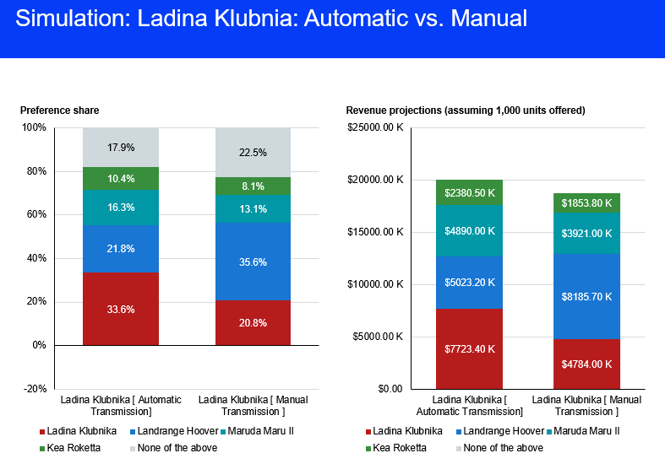

**Insight:** The preference share of Ludina Klubnika is much higher for Automatic transmission compared to the manual transmission at 33.6% compared to 20.8%. Most of this preference share goes to Landrange Hoover again.

The revenue projection is $7.7 million for the automatic transmission variant of the Ludina Klubnika compared to only $4.8 million for the manual transmission.